Literary Criticism Concept Map

In order to help prepare you for your unit test, you will consolidate your understanding of the different schools of literary criticism by creating a concept map.

What is a concept map?
A concept map is a visual representation that illustrates how one understands relationships between concepts.

Essential characteristics:

1) Start with a major term or idea from which the next term or idea extends either in hierarchical or radiating format.
2) Shift is from a more complex to a less complex idea or a major idea to a minor idea. It often ends with an example.
3) Connecting line is drawn between concepts.
4) Linking words are placed on lines stating the relationship between concepts.
5) Cross links between one segment of the concept hierarchy or classification and another.

Non-Essential characteristics:
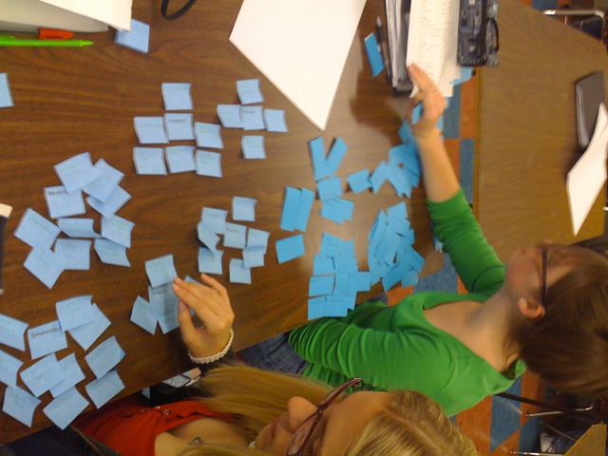
1) Colour to clarify segment areas or ideas that relate.
2) Examples of the concept being presented.

Steps:
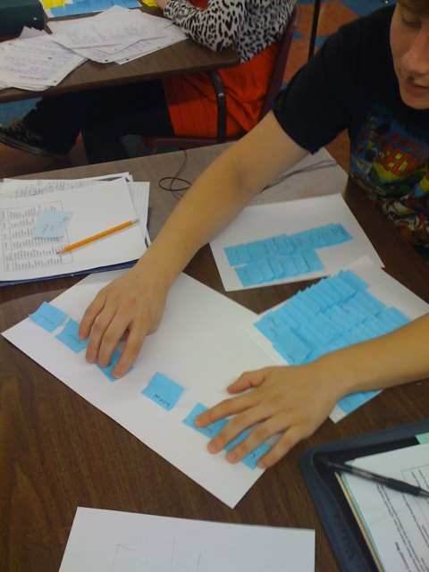
1) Brainstorm the key ideas (see your notes on Literary Criticism)
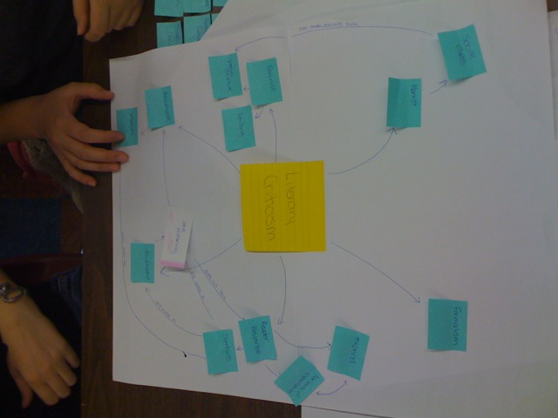
2) Put ideas onto post-it notes. Once ideas are on post-its, begin to sort and classify these post-its, looking for relationships between ideas. Feel free to look around and see how other people are sorting.
3) Transfer the post-its to a piece of paper. Draw lines between the concepts and place words on lines that illustrate your thinking about the relationships between the concepts.
4) Look for cross links between different concepts.

Linking words:
is part of can be can effect detected by
follows precedes is like similar to
includes excluded from example is
same as influences
is greater than leads to incorporated into connects need produces have

Brainstorming: For each of the theories, write down as many key words and terms that you can think of.
Reader Response

Formalism

Feminism

Archetypal

Postcolonialism
Postmodernism

Psychoanalytical

Queer Theory

Ecocriticism
Marxism

